**WHAT IS ITIL?**

ITIL is best practice in IT Service Management, developed by OGC (Office of Government Commerce) and supported by publications, qualifications and an international user group. ITIL is intended to assist organizations to develop a framework for IT Service Management. Worldwide, ITIL is the most widely used best practice for IT Service Management. Current editions of the ITIL library can be purchased in print or CD format or as an intranet license.

ITIL (the IT Infrastructure Library) is essentially a series of documents that are used to aid the implementation of a framework for IT Service Management. This customizable framework defines how Service Management is applied within an organization. ITIL is a best practice framework that has been drawn from both the public and private sectors internationally.

It describes how IT resources should be organized to deliver business value, documenting the processes, functions and roles of IT Service Management (ITSM).

Although ITIL was originally created by the CCTA, a UK Government agency, it is now being adopted and used across the world as the standard for best practice in the provision of IT Service. Although the ITIL covers a number of areas, its main focus is on IT Service Management.

ITIL advocates that IT services are aligned to the needs of the business and support its core processes. It provides guidance to organizations and individuals on how to use IT as a tool to facilitate business change, transformation and growth.

[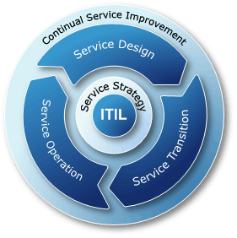](http://www.google.co.za/url?sa=i&rct=j&q=&esrc=s&source=images&cd=&cad=rja&uact=8&ved=0CAcQjRw&url=http://www.itsmwatch.com/itil/article.php/3913896/Integrating-ITIL-with-IT-Project-Management-Improves-Both.htm&ei=rotgVeCBLMjH7Aav64LwBA&bvm=bv.93990622,d.ZGU&psig=AFQjCNE0rIAYdXb1LynmDPZv7XM7jZE_RQ&ust=1432476257348174)

The ITIL best practices are currently detailed within five core publications:

•ITIL Service Strategy

•ITIL Service Design

•ITIL Service Transition

•ITIL Service Operation

•ITIL Continual Service Improvement.

These five volumes map the entire ITIL Service Lifecycle, beginning with the identification of customer needs and drivers of IT requirements, through to the design and implementation of the service and finally, the monitoring and improvement phase of the service.

ITIL (IT Information Library) is a framework proposed by the United Kingdom's OGC (Office of Government Commerce) that gathers together in a series of books the best practices in the area of managing IT services. The ITIL library was started in the early 1980s by the British government with the goal of improving the service provided by their IT departments.

The goal of ITIL is to provide the managers of IT systems with the tools and documents that will allow them to improve the quality of their services, i.e. improve client satisfaction while meeting the strategic goals of their organization. To do this, the IT department must be considered to be a series of closely linked processes. Pragmatically, ITIL meets the logic of making IT serve employees and clients rather than the other way around.

IT departments are not the only organizations benefitting from the ITIL approach because this approach consists in making IT departments aware of the fact that the quality and availability of the IT infrastructure has a direct impact on the overall company quality.

**Roles of ITIL**

It describes processes, procedures, tasks, and checklists which are not organization-specific, but can be applied by an organization for establishing integration with the organization's strategy, delivering value, and maintaining a minimum level of competency.

It allows the organization to establish a baseline from which it can plan, implement, and measure.

It is used to demonstrate compliance and to measure improvement.

ITIL Roles are employed in order to define responsibilities. In particular, they are used to assign Process Owners to the various ITIL processes, and to illustrate responsibilities for the single activities within the detailed process descriptions.

The definitions found here (in alphabetical order) are meant to be short, summing up the main characteristics of a specific ITIL role according to ITIL 2011 (ITIL V3 2011 Edition).

When in-depth information on a role's tasks and responsibilities is required this can, in our view, best be obtained from the ITIL process flows.

**Popular ITIL roles**

|  |  |
| --- | --- |
| **ITIL Role** | **Definition** |
| [Incident Manager](http://wiki.en.it-processmaps.com/index.php/ITIL_Roles#Incident_Manager) | * The Incident Manager is responsible for the effective implementation of the Incident Management process and carries out the corresponding reporting. |
| [Problem Manager](http://wiki.en.it-processmaps.com/index.php/ITIL_Roles#Problem_Manager) | * The Problem Manager is responsible for managing the lifecycle of all Problems. His primary objectives are to prevent Incidents from happening, and to minimize the impact of Incidents that cannot be prevented. |
| [Change Manager](http://wiki.en.it-processmaps.com/index.php/ITIL_Roles#Change_Manager) | * The Change Manager controls the lifecycle of all Changes. His primary objective is to enable beneficial Changes to be made, with minimum disruption to IT services. |
| [Business Relationship Manager](http://wiki.en.it-processmaps.com/index.php/ITIL_Roles#Business_Relationship_Manager) | * The Business Relationship Manager is responsible for maintaining a positive relationship with customers, identifying customer needs and ensuring that the service provider is able to meet these needs with an appropriate catalogue of services. |
| [Project Manager](http://wiki.en.it-processmaps.com/index.php/ITIL_Roles#Project_Manager) | * The Project Manager is responsible for planning and coordinating the resources to deploy a major Release within the predicted cost, time and quality estimates. |
| [Service Level Manager](http://wiki.en.it-processmaps.com/index.php/ITIL_Roles#Service_Level_Manager) | * The Service Level Manager is responsible for negotiating Service Level Agreements and ensuring that these are met. |

**ITIL roles - Service Strategy**

**Business Relationship Manager**

The Business Relationship Manager is responsible for maintaining a positive relationship with customers, identifying customer needs and ensuring that the service provider is able to meet these needs with an appropriate catalogue of services.

The Business Relationship Manager works closely with the Service Level Manager.

The Business Relationship Manager has been introduced as a new role in ITIL 2011.

**Demand Manager**

The role Demand Manager has been introduced in ITIL 2011 to perform the activities in the Demand Management process.

The Demand Manager is responsible for understanding, anticipating and influencing customer demand for services.

The Demand Manager works with capacity management to ensure that the service provider has sufficient capacity to meet the required demand.

**Financial Manager**

The Financial Manager is responsible for managing an IT service provider's budgeting, accounting and charging requirements.

**IT Steering Group (ISG)**

The IT Steering Group (ISG) sets the direction and strategy for IT Services. It includes members of senior management from business and IT.

The ISG reviews the business and IT strategies in order to make sure that they are aligned.

It also sets priorities of service development programs/ projects.

Service Portfolio Manager

The Service Portfolio Manager decides on a strategy to serve customers in cooperation with the IT Steering Group, and develops the service provider's offerings and capabilities.

Service Strategy Manager

The Service Strategy Manager supports the IT Steering Group in producing and maintaining the service provider's strategy.

This role is also responsible for communicating and implementing the service strategy.

The Service Strategy Manager has been introduced as a new role in ITIL 2011.

**The Scope of ITIL**

ITIL is divided into nine areas (that correspond to nine books) that cover all of the problems encountered by IT systems managers. The first two (in bold) are considered to be the core of the ITIL method:

* Service Support
* Service Delivery
* Infrastructure Management
* Applications Management
* Service Management
* Business Perspective
* Business Requirements
* Technology

**Service Support**

The Service Support area deals with the operation and support of the IT infrastructure. It is broken down into the following six processes:

ITIL – Introducing continual service improvement

The objectives of continual service improvement Service improvement must focus on increasing the efficiency, maximizing the effectiveness and optimizing the cost of services and the underlying IT service management processes. The only way to do this is to ensure that improvement opportunities are identified throughout the entire service lifecycle. The primary purpose of Continual Service Improvement (CSI) is to continually align and re-align IT services to the changing business needs by identifying and implementing improvements to IT services that support business processes. CSI looks for ways to improve process effectiveness, efficiency and cost effectiveness. Other objectives include:  Review, analyze and make recommendations on improvement opportunities in each lifecycle phase: z Service strategy z Service design z Service transition z Service operation z and CSI itself!  Identify and implement individual activities to improve IT service quality and improve the efficiency and effectiveness of enabling ITSM processes  Improve cost effectiveness of delivering IT services without sacrificing customer satisfaction  Ensure applicable quality management method is used

[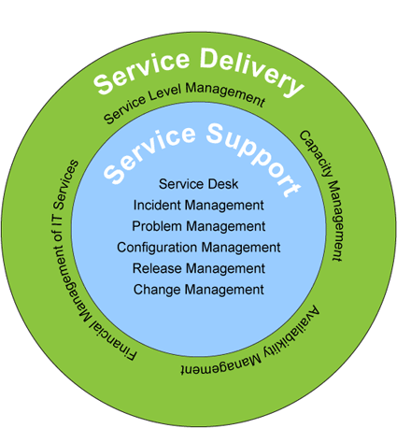](http://www.google.co.za/url?sa=i&rct=j&q=&esrc=s&source=images&cd=&cad=rja&uact=8&ved=0CAcQjRw&url=http://www.trackersuite.net/itil_tsnet.html&ei=IYxgVabYJ5Cu7Abm9IN4&bvm=bv.93990622,d.ZGU&psig=AFQjCNEdfxt1PuakkcN5bk6FyUWiUDtptA&ust=1432477083528276)

**The scope of continual service improvement**

There are three main areas that CSI needs to address:

* The overall health of IT service management as a discipline
* The continual alignment of the portfolio of IT services with the current and future business needs
* The maturity of the enabling IT processes for each service in a continual service lifecycle model

The activities of continual service improvement

Reviewing management information and trends to ensure that services are meeting agreed service levels

Reviewing management information and trends to ensure that the output of ITSM processes are achieving the desired results

Conducting maturity assessments against the process activities and roles to highlight areas of improvement or concern

Conducting internal audits verifying compliance

Conducting external and internal service reviews to identify CSI opportunities

Reviewing analyzed data

Presenting recommendations to senior management for improvement

Helping priorities improvement opportunities

Leading managing and delivering cross functional and cross divisional improvement projects

Building effective relationships with the business and IT senior managers

Influencing all levels of management to ensure that service improvement activities are receiving the necessary support and are resourced sufficiently to implement solutions

**ITIL Processes according to ITIL Version 2 (ITIL V2)**

Unlike ITIL V3 2011 and 2007, IT Service Management according to ITIL version 2 was not organized around the service lifecycle. ITIL V2 contained the following "disciplines":

Service Support The ITIL discipline Service Support provides all operative Processes necessary for the handling of Service interruptions and for the implementation of Changes; the availability of the IT Services is thereby guaranteed.

Service Delivery the ITIL discipline Service Delivery ensures that binding rules for the operative Processes are in existence. It regulates the planning, contractual and financial topics.

[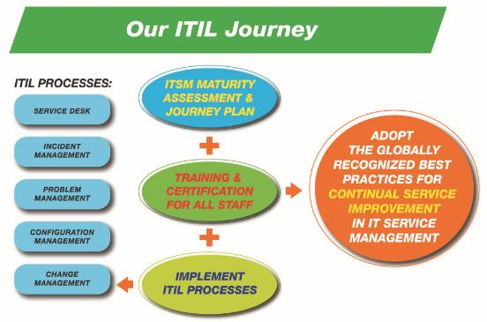](http://www.google.co.za/url?sa=i&rct=j&q=&esrc=s&source=images&cd=&cad=rja&uact=8&ved=0CAcQjRw&url=http://www.its.hku.hk/services/itil&ei=joZgVduDEK2v7Aad_4GgBA&bvm=bv.93990622,d.ZGU&psig=AFQjCNHPxzgywxkfcLZk-y67t1NFqVW3Ww&ust=1432475605270443)

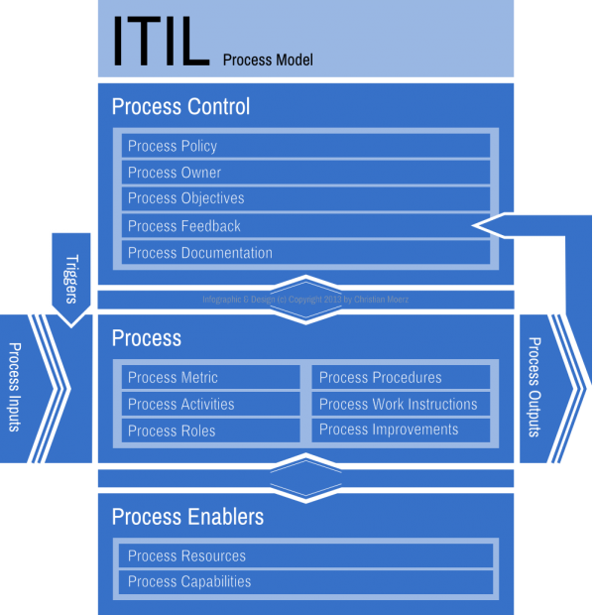

**ITIL Process Management**

Ensuring that all ITIL processes as a whole work together in a seamless way

Providing adequate tools for managing processes

Making sure that the ITIL processes are sufficiently documented

Helping IT staff to improve their processes

In the absence of any existing facilities, a suitable member of IT staff must be selected for this role – the person in charge of the ITIL implementation project is frequently considered a good choice.

**WHAT IS MEANT BY ‘IT SERVICE MANAGEMENT’?**

IT Service Management is a top-down, business-driven approach to the management of IT that specifically addresses the strategic business value generated by the IT organization and the need to deliver a high quality IT service. IT Service Management is designed to focus on the people, processes and technology issues that IT organizations face.

**WHO IS ITIL FOR?**

ITIL is aimed at:

IT service providers

IT directors and managers

CIOs

[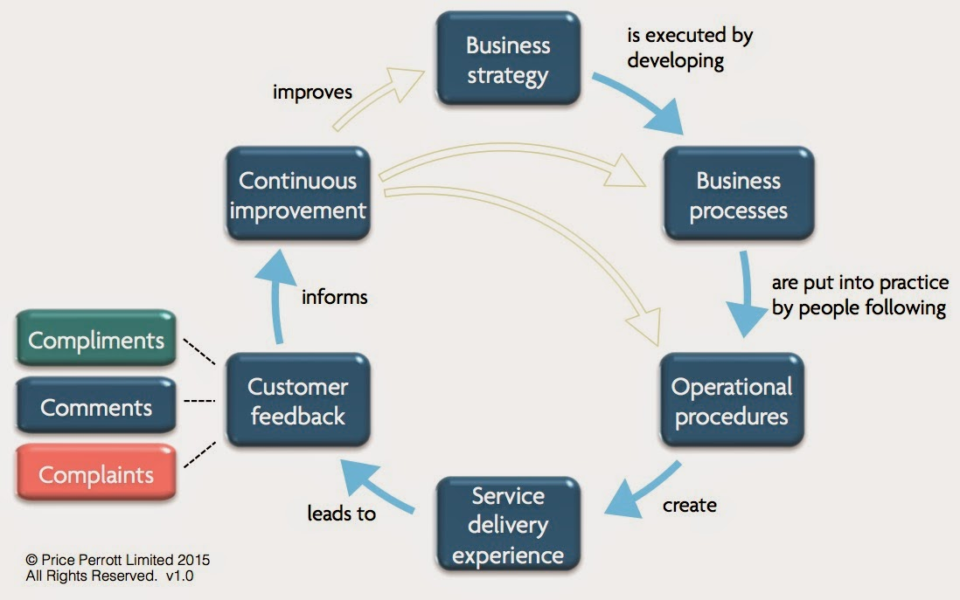](http://www.google.co.za/url?sa=i&rct=j&q=&esrc=s&source=images&cd=&cad=rja&uact=8&ved=0CAcQjRw&url=http://customer-service-experience.blogspot.com/2015/01/improving-service-performance-1.html&ei=GZJgVbmwK4Wd7Aa78oDICw&bvm=bv.93990622,d.ZGU&psig=AFQjCNGJRh0hNCMlltTn6D6DAKQ3sUygrw&ust=1432477192978654)

**IT WILL ALSO INFORM:**

Business managers

Customers & end-users involved in building good relationships with their IT service providers

Plus any organization that depends on IT Services.

**WHAT ARE THE BENEFITS OF USING ITIL?**

ITIL provides a systematic and professional approach to the management of IT service provision. Adopting its guidance can provide such benefits as:

Reduced costs

Improved IT services through the use of proven best practice processes

Improved customer satisfaction through a more professional approach to service delivery

Standards and guidance

Improved productivity

Improved use of skills and experience

Improved delivery of third party services through the specification of ITIL.

**Who uses itil?**

The ITIL approach has also been adopted by hundreds of organizations world-wide, including Microsoft, IBM, Barclays Bank, HSBC, Guinness and Procter & Gamble.

Here are a few of the positive results that can arise from implementation of ITIL certification:

Efficiency: Better, streamlined, more efficient IT service.

**HOW DOES ITIL WORK AND WHAT ARE THE OUTCOMES?**

Working with ITIL will help deliver:

**Customer-focused services** - ITIL identifies all internal stakeholders in the project to ensure that their aims are met as well. By taking such a rigorous approach at the planning stage, systems work smoothly, freeing up staff to concentrate on delivery.

**Cost effectiveness** - Even working within tight budgets, you'll be able to deliver a higher quality IT service. This is because potential problems at all levels - planning, implementation and operations - can be identified.

**Increased motivation and productivity** - The ITIL approach gives IT staff the confidence to see what they do as a professional discipline as opposed to "just another job". By applying well-worked and practical systems to IT planning and implementation, staff begin to appreciate what they have achieved, creating a virtuous cycle of learning, planning and implementation.

**What ITIL services can Covestic provide?**

Covestic utilizes Information Technology Infrastructure Library (ITIL) processes, and proven best practices to help organizations determine how they can optimize their IT operations to provide increased value to the business. Covestic has a long list of ITIL implementation successes in a variety of industries including financial services, automotive, and technology.

**Records management**

